**Linking Test Cases to Requirements**

**Click on requirements coverage**

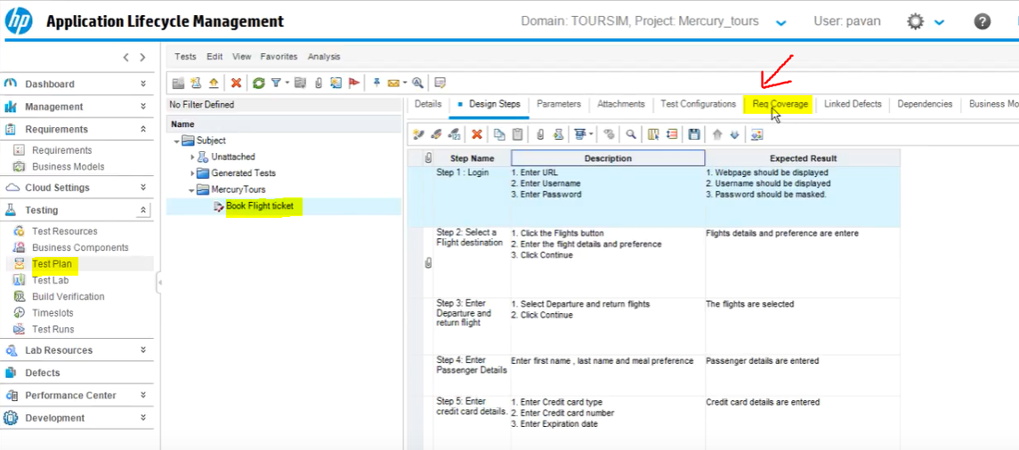

**Click on Select Requirement**



**Requirements Tab will open on the right, we can select the requirement we wat to link with our test case and click on green arrow.**

**You may be able to link the test case to more than 1 requirements**

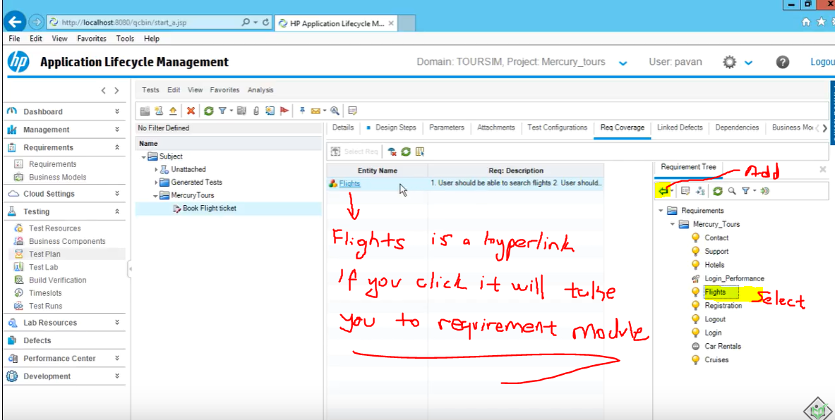

**When you click it will take you to the Requirement Module,**

**There click on the Test Coverage, you will see the linked tests**

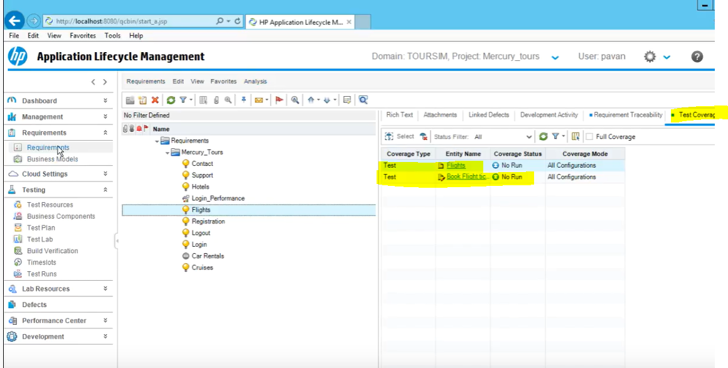

**You can delete the link either from test coverage in req, or req coverage in test plan**

**They both will be deleted on both side**